Each section should have it's own Github Classroom assignment.

Create an assignment as you normally do. Fill in the Assignment title and select Group Assignment. For the project, I suggest "<section>-project"
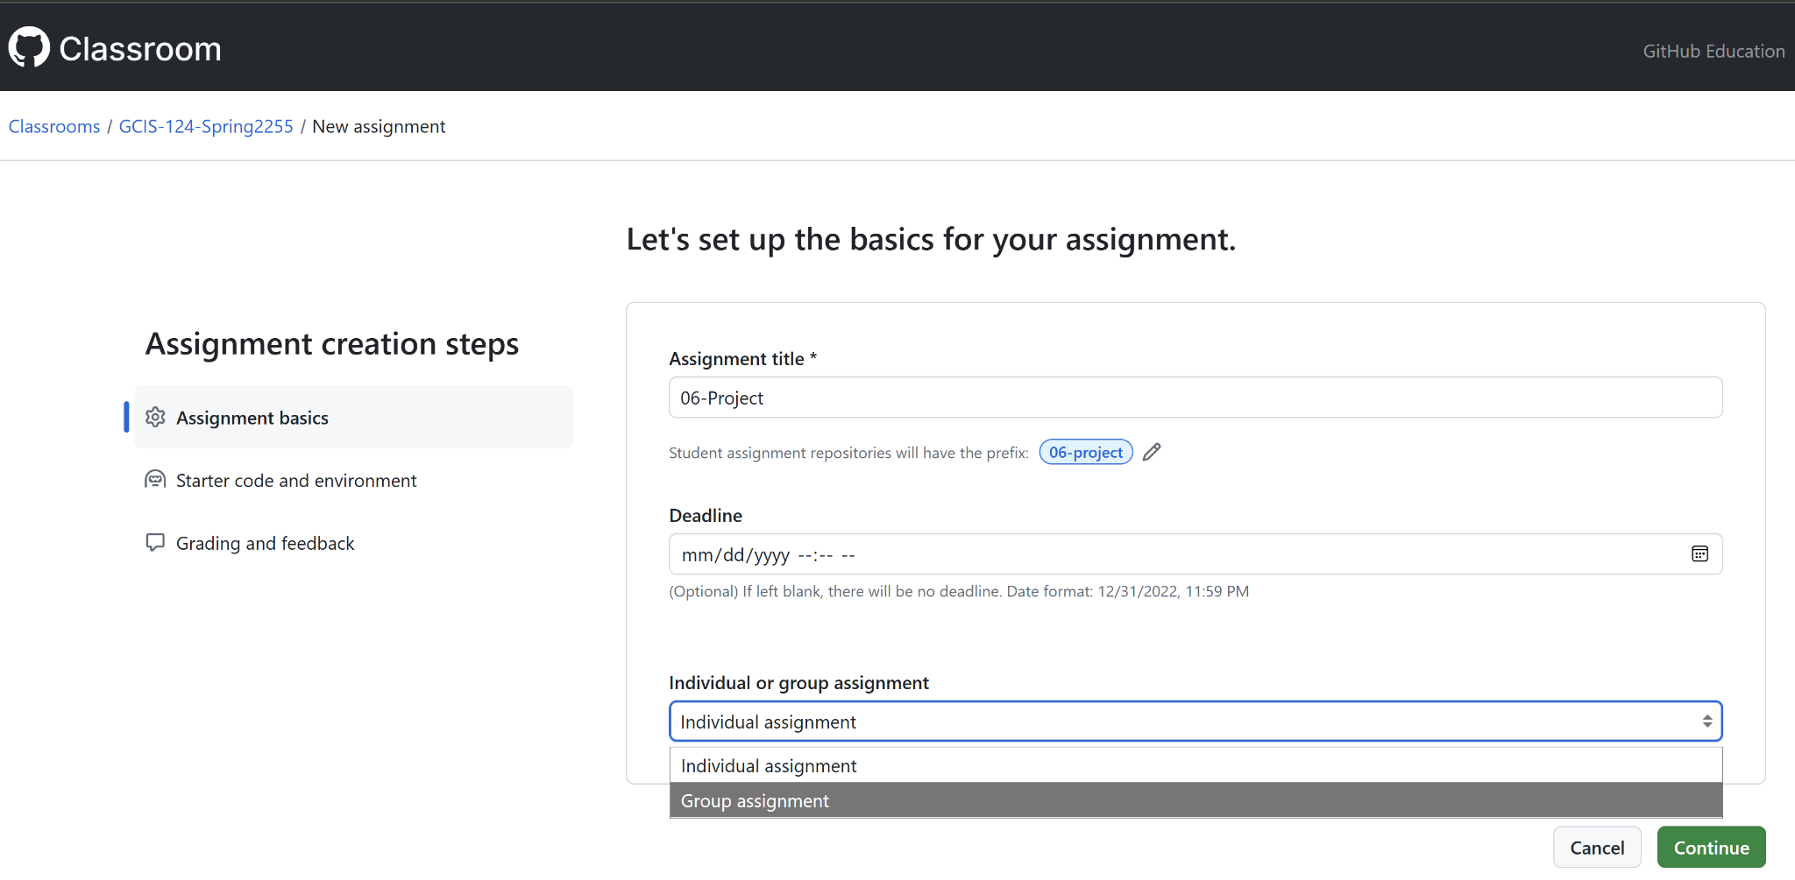

Once you select Group assignment, the dialog below will appear. Give a name for your set of teams. This is just a container and not the actual team names. Click Continue.
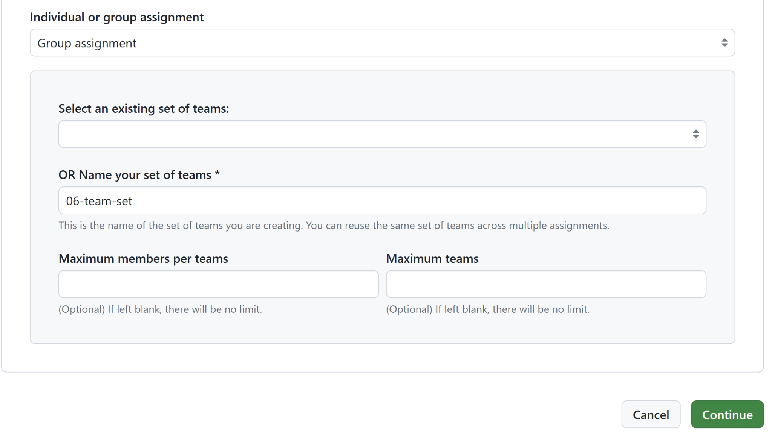
Provide the template repository, per usual
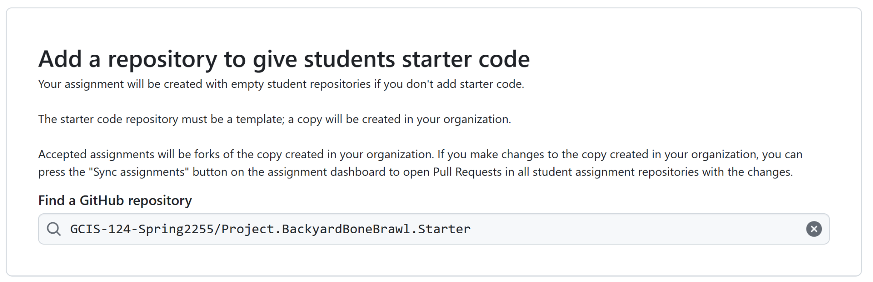

Continue all the way through to the end to create the assignment.

These instructions are in the project kick-off deck, but I'll repeat them here:
- When the first student from each team accepts the github classroom assignment, they should create a team with their agreed upon team name. Their repo will be <Assignment Title>-<team name>. So if the assignment title was "06-Project" and the team name "Matrix", their repo will be named "06-project-matrix".
- Once the team is created, subsequent members should select that team.

